# How to use GitHub

1. **Register on GitHub**

If not registered, register here: <https://github.com/>. Then tell me your username, and I will add you to our repository, so that you can contribute to it.

1. **Install client**

I strongly commend you to use SourceTree: <http://www.sourcetreeapp.com/>. It’s a Git management software with very friendly GUI, which can free our work from command-lines.

1. **Local setup**
   1. Install embedded Git

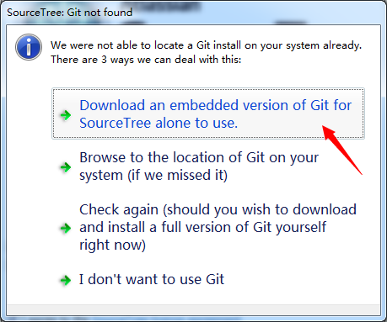

* 1. Skip install embedded Mercurial

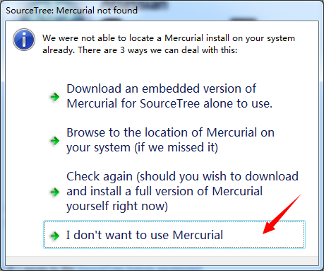

* 1. Input your user personal information

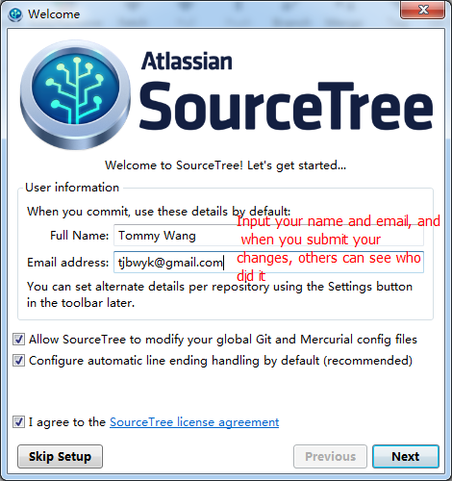

* 1. choose SSH configuration

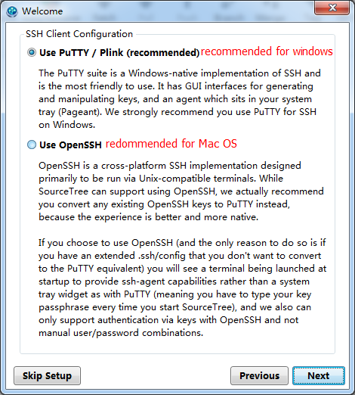

* 1. Connect to GitHub

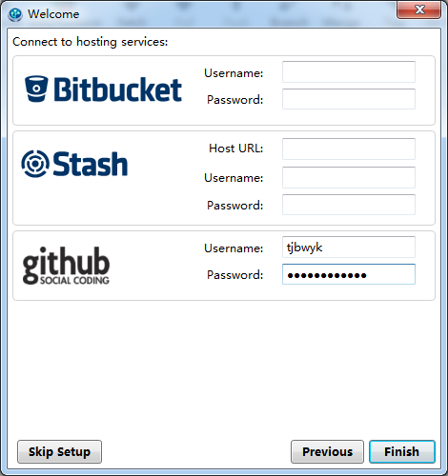

* 1. Setup SSH key (if you already have one, just import it, skip to ii)
     1. Generation

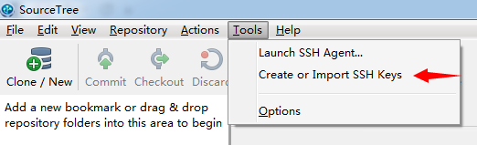

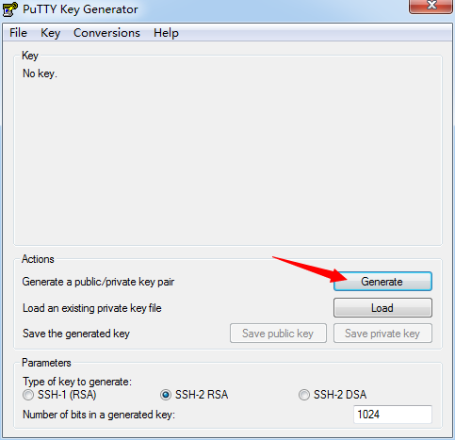

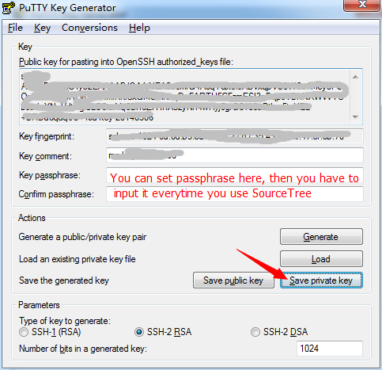

* + 1. Put the SSH Key into SourceTree

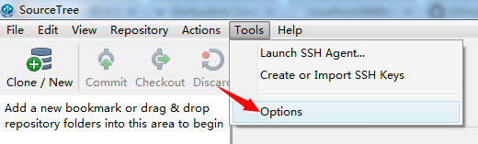

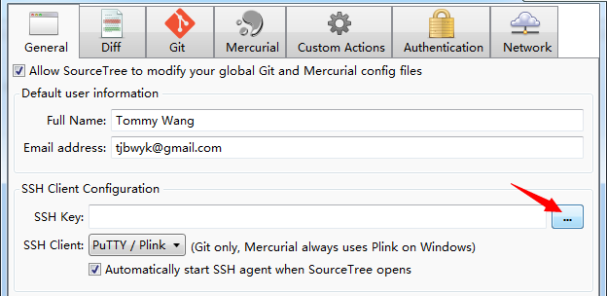

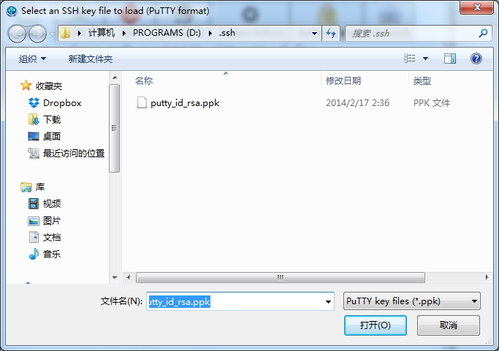

* 1. Download our project

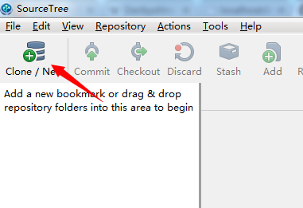

Repository URL: <https://github.com/tjbwyk/infovis.git>

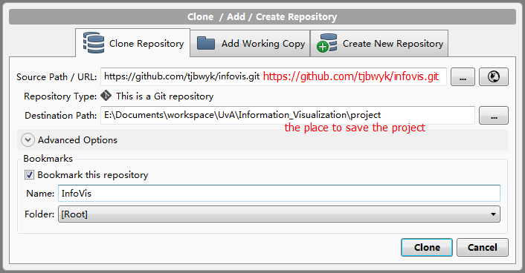

Done. Now you can see all the files in the folder you choose.

1. **How to submit your changes**

When you have made some changes, you do the following two steps to submit

* 1. Commit

Choose the files you want to submit and leave some message about your changes. After this, the changes will be cached locally.

* 1. Push

Submit your local cached changes to the server

1. **How to keep your code up-to-date**

When someone else made changes on the server, you can update your local code with the Pull (you can see the number of changes beside the button) operation.

1. **Create your own branch**

It’s always better to keep the **master** branch a runnable one. So when you test your own codes, I recommend you to create and maintain a **sub-branch** from master. With your own branch, you can do all the same things as master. In addition, you can merge master directly to your branch to keep your branch up-to-date. And when you have a runnable version of your branch, you can merge it to master.

* 1. Merge

To merge branch B to branch A, you should

1. be on branch A
2. click the merge button
3. select branch B
4. merge
5. **About conflicts**

When you push, pull and merge branches, it’s common to see some conflicts. And those will be shown in one file with labels. You should decide which to keep and which to delete. After solving the conflicts, just commit and push again.

Cheers,

Yikang Wang